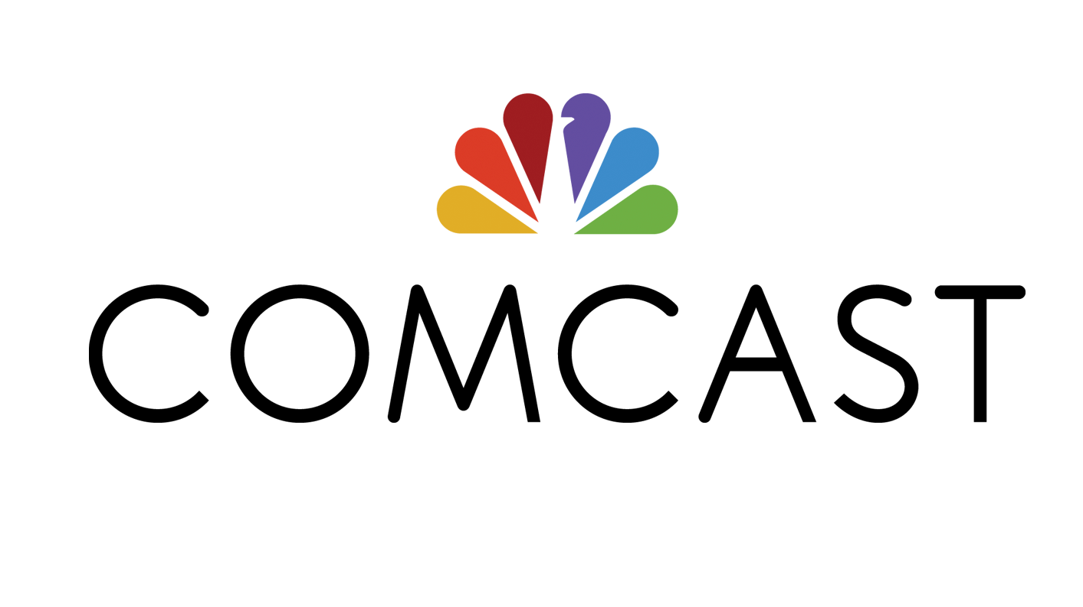

Comcast Brings its Advanced Network and Services to the Elk Grove Technology Park, giving Manufacturers onsite access to State-of-the-Art Information and Communications Technologies

Fiber provides access to fast Internet speeds, Ethernet, Cloud Services and Comcast Business SmartOffice

ELK GROVE VILLAGE, IL – July 11, 2019 – Comcast Business announced today that its bringing its advanced network to the Elk Grove Technology Park, a $1 billion technological innovation and business development hub located in Chicago’s northwest suburbs near O’Hare International Airport.

Comcast Business, which partnered with industrial developer Brennan Investment Group to bring its fiber right to the park’s doors, will be the first connectivity provider onsite and will offer a broad range of secure, reliable and scalable data, voice and video solutions to tenants, including: internet and ethernet, cloud solutions, business phone and TV services, as well as its Comcast Business SmartOffice* video monitoring system. Through these services, tenants will have access to fast internet speeds, the ability to build custom network infrastructures and customized solutions to stay connected.

“Thanks to our partnership with Comcast Business, our tenants will have a state-of-the-art network and advanced technology solutions available when they move in,” said Jack Brennan, First Vice president for CBRE, the park’s exclusive representative. “These services will help us attract a new wave of advanced manufacturing companies to the park.”

“Elk Grove Village sits on the edge of O’Hare International airport and major rail and road networks, which is why 5,600 businesses have chosen to locate here. The Elk Grove Technology Park will build on the village’s position as the premier destination for industrial and manufacturing companies in the Chicago area and Midwest,” said Elk Grove Village Mayor Craig Johnson. “The bronze elk statues in the park recall the village’s heritage, while the connectivity and technology demonstrate where we’re headed: the home of the future of innovative manufacturing.”

“Manufacturing has played a key role in the Chicago area’s economy for more than two hundred years and was largely responsible for putting the region on the global map. The Elk Grove Technology Park will be transformational, because it will usher in new era of technology-based manufacturing that will help drive our economy forward,” said Sean McCarthy, Comcast’s regional vice president of Business Development and Strategic Initiatives. “Our portfolio of business solutions will align with the needs of companies in the park, helping to optimize their performance, reduce the complexity of day-to-day tasks and accelerate their growth.”

About Comcast Business
Comcast Business offers Ethernet, Internet, Wi-Fi, Voice, TV and Managed Enterprise Solutions to help organizations of all sizes transform their business. Powered by an advanced network, and backed by 24/7 customer support, Comcast Business is one of the largest contributors to the growth of Comcast Cable. Comcast Business is the nation’s largest cable provider to small and mid-size businesses and has emerged as a force in the Enterprise market; recognized over the last two years by leading industry associations as one of the fastest growing providers of Ethernet services.
For more information, call 866-429-3085. Follow on Twitter @Comcast Business and on other social media networks at http://business.comcast.com/social.
With more than 6,000 local employees, Comcast’s Greater Chicago Region (https://chicago.comcast.com) serves customers in central and northern Illinois, including Elk Grove Village and the rest of the Chicago area, northwest Indiana and southwest Michigan. “Like” Comcast’s Greater Chicago Region on Facebook by visiting @Comcast. “Follow” Comcast’s Greater Chicago Region on Twitter at @ComcastILLINOIS.
* Comcast Business SmartOffice Licenses: AL: 001785, 001789; AR: 2536; AZ: ROC 307346, BTR 18286-0; CA: CSLB 1028256, ACO 7677; CT: ELC 0189754-C5, ELC 0202487-C5; DE:SSPS 13-225; FL: EF0000279; GA: LVU406354; IL: PACA 127-001555; LA: F2257; MA: 7067C, SS-002525; MD: 107-1937; ME: LM50017039; MI: 3601206519; MN: TS674413; MS: 15030170; NC: 1937-CSA; NJ: Burglar Alarm Business Lic. # 34BF00052000; NM: 379095; NY: licensed by the N.Y.S. Department of State 12000317423; OR: CCB 199939; SC: BAC-13662; TN: ACL 2006, ACL 2002; TX: B18966; UT: 8788186-6501; VA: 2705151177, DCJS 11-15181; VT: ES-02366; WA: COMCABS846NU; WASHINGTON, DC: ECS 904217, BBL 602517000001; WV: WV051524. Valid 10/11/18. See www.business.comcast.com/smartoffice for current list.

# # #
Media Contacts:
Jack Segal
Comcast
773.304.8243
jack_segal@cable.comcast.com

Chloe Huard
Finn Partners
586.876.6551
chloe.huard@FinnPartners.com

